**MRI zero**

**5.11. MRFzero live test 48 x 48 : TI 1,2,10**

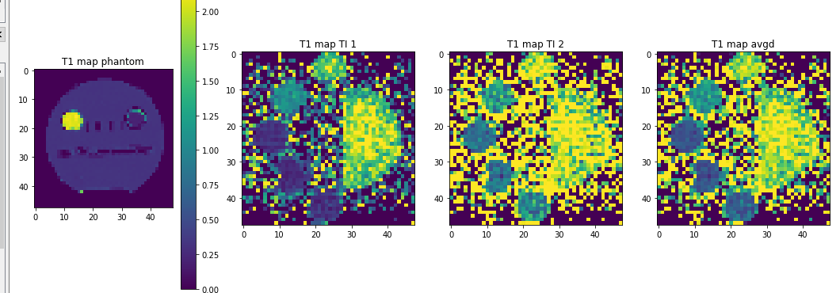

**TI 0,0,0**

|  |  |
| --- | --- |
|  |  |
|  |  |
|  |  |
|  |  |
|  |  |
|  |  |
|  |  |
|  |  |
| No improvemnet anymore from NN only, try now TI opt | seqNN TI [ 0.0068, -0.0502, 0.0107] |
|  | Vllt wars das reparametrize?  Oder batch size? |
|  |  |

**25.10.2019**

We changed some normalization in the script **e33** for now.

Also we added a FID prescan for a coarse intensity normalization in core.FID_normscan

we think once we solve the normalization, we can solve any NN problem also for real data

So some thoughts about this norm:

We want the following to be true for normalized data:

1. Every voxel yields a value = normed_value between 0 and 1
2. This value should be independent of the voxel size

To achieve this:

We have a normalization FID scan of the same volume, which for each imaging sequence has to be measured once and will be stored as .npy

1. Fulfilled by signal =signal_seq/signal_FID
2. Fullfiled by signal =signal_seq/signal_FID * voxelsize /FOV

In core.FID_norm

np.save("auxutil/normsim.npy", normsim)

At the scanner until now: voxelsize = 1 independent of resolution

Thus we need to do a normalization before adjoint:

scanner.forward_fast(spins, event_time)

scanner.signal=scanner.signal/NVox

scanner.adjoint()

actually for the full normalization not important if FID is scanned with the same phantom matrix, but we want a low res sim maybe.

**10.7.2019**

|  |  |
| --- | --- |
| **Bssfp with R2*=0** | **Bssfp with R2*=30** |
|  |  |
| Observation: smaller rings appüear with less R2* |  |

**1degree with four dummy scans:, still weird pockets in sim**

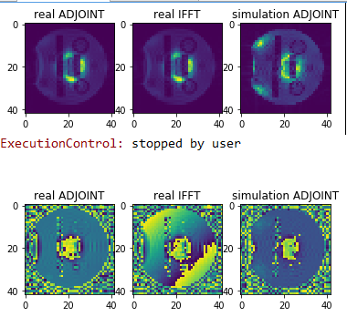

**This pockets seem to be slight variations in dB0, but why are they moving outside the phantom? Ghosting?**

* **Do GRE phase mapping adjust B0 every time**
* **Find out why we see non-zero phase**
* **What is the contstant phase offset? Compare to GRE and RARE**

**6.05.2019**

I did many scans last night and ran into several problems.

# RARE:

Target RARE looks fine:



**Figure1: seq190506\t03_tgtRARE_tskRARE_32_linearlowSAR_8 seqiter1.seq**

Still, there was a problem for lowsar RARE for the that the refocuse detection ‘use’ did not work properly. Still this should be only a phase problem and not affect the magnitude image.

Even for very small changes in RF (due to low SAR task), difference between simulation and meas can be seen. As shown in the figure 2 below. The meas here was way more stable than the sim.

 **Figure2: seq190506\t03_tgtRARE_tskRARE_32_linearlowSAR_8 seqiter6.seq**

So there was a mismatch between sim and meas. If I bow check the task where the 180 were set to 0 and the task was to recover (seq190506\t03_tgtRARE_tskRARE_32_linearprtrb_no_refoc)

**\\mrz3t\upload\CEST_seq\pulseq_zero\sequences\**seq190506\t03_tgtRARE_tskRARE_32_linearprtrb_no_refoc\a_t03_tgtRARE_tskRARE_32_linearprtrb_no_refoc_full.gif

It is the other way round, none of the meas actually look like the reconstructed SIM.



The biggest difference is actually the phases / signs of flips, so could it be that the phases are not correctly played out at the scanner? We can check that in the pulseq file seqiter92.seq.

*# Format of RF events:*

*# id amplitude mag_id phase_id delay freq phase*

*# .. Hz .... .... us Hz rad*

*[RF]*

*1 250 1 2 0 0 1.5708*

*2 364.446 1 3 0 0 -0.0341712*

*3 160.028 1 2 0 0 3.13476*

*4 454.606 1 3 0 0 -0.104827*

*5 182.507 1 2 0 0 -0.248737*

*6 531.586 1 2 0 0 -0.0714023*

*7 245.259 1 3 0 0 0.0823185*

*8 264.382 1 3 0 0 0.0287636*

*9 512.249 1 3 0 0 0.066199*

*10 188.069 1 3 0 0 3.20698*

*11 187.645 1 2 0 0 0.0308042*

*12 211.786 1 2 0 0 0.0150039*

*13 229.973 1 2 0 0 0.00866167*

*14 491.012 1 2 0 0 -0.00832324*

*15 187.582 1 2 0 0 -3.14954*

*16 303.735 1 3 0 0 -0.00401756*

*17 357.866 1 3 0 0 0.0015757*

*18 425.722 1 3 0 0 -0.00190998*

*19 484.034 1 3 0 0 -0.000801292*

*20 498.841 1 3 0 0 -0.00634431*

*21 474.909 1 3 0 0 -0.00130949*

*22 471.27 1 3 0 0 8.72286e-05*

*23 480.689 1 3 0 0 -0.00163589*

*24 481.509 1 3 0 0 -0.000331597*

*25 451.036 1 3 0 0 0.00551908*

*26 447.53 1 3 0 0 0.00351929*

*27 441.089 1 2 0 0 0.00871723*

*28 406.653 1 3 0 0 -3.13254*

*29 459.101 1 3 0 0 3.13631*

*30 513.738 1 3 0 0 -0.00972012*

*31 288.529 1 3 0 0 0.000340765*

*32 373.159 1 2 0 0 -3.16282*

*33 0.89761 1 2 0 0 -1.60443*

What is obvious is that phases actually change, but there are no signs in the amplitudes. Thus pulseq calculates the flips always into a abs(flip) and changes the respective phase. This is for a sign change just an increment of 180 degrees it seems. Last event for example: should be -10° phase or so, but is -190°.

**So QUESTION for ALEX:**

**Could it be that this somehow kills the reco because the rot ADC rot factor/adjoint has now the wrong angle? We could try to use the phase angle from pulseq to fix the adjoint reco…**

# GRE

We seem to have still many differences between sim and real meas. Reminds me of the first recos before we were using pulseq gradmoms… Very bad.

Check the gifs:

\\mrz3t\upload\CEST_seq/pulseq_zero/sequences/seq190506/e14_pitcher_ortho_opt/pitcher_ortho_opt_full.gif

* Very bad reco when sim looks good.

\\mrz3t\upload\CEST_seq/pulseq_zero/sequences/seq190506/e14_fast_optpitcher/e14_fast_optpitcher_full.gif

* Looks roughly good, but adc outside k range seems to kill it, why?

Phases were not properly exported, also slab selection comes with stronger gradients (z) as in sim.

# bSSFP

For some reason the meas looks here now extremely good. And the sim shows bandings and everything.

Bssfp even with disturbance always looks very nice, and has almost no artifacts.

\\mrz3t\upload\CEST_seq/pulseq_zero/sequences/seq190506/e24_tgtBSSFP_tskBSSFP_perturbed_initfrom_TGT/e24_tgtBSSFP_tskBSSFP_perturbed_initfrom_TGT_full.gif

Sim definitely shows pi artifact, but not meas.

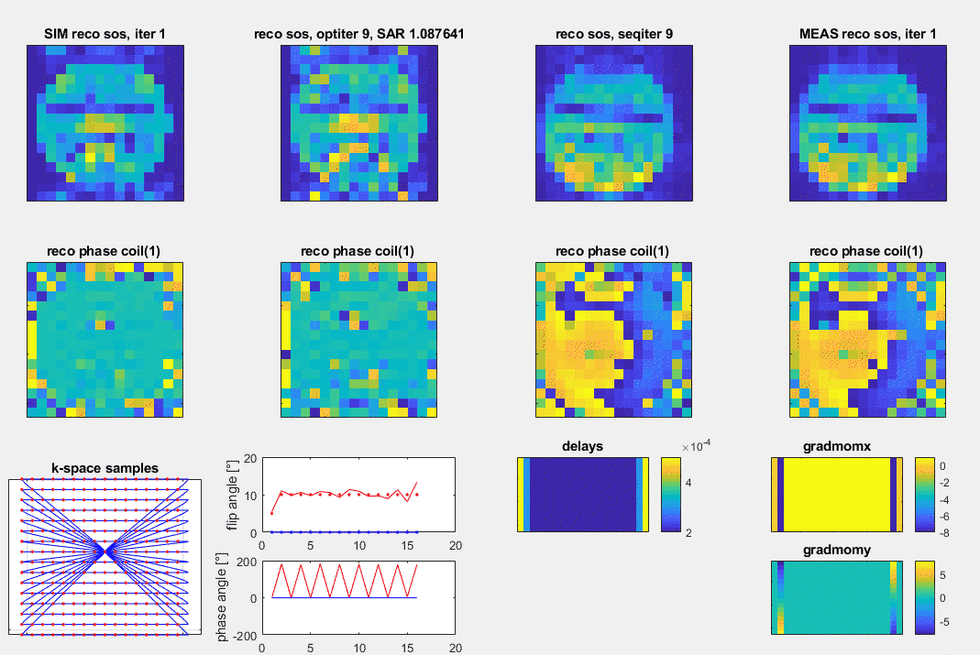

Phases seem to be not properly exported. Also I used slab selective bat file, which of course is not a balanced ssfp but spoiled due to the z-gradients of the slab selection …

Also phase was fucked up during export! So all bssfp and gre again and

Can be reexported and remeasured.

**17.04.2019**

I understand mow the y axis in the central ROI. It is the inhomogeneity.

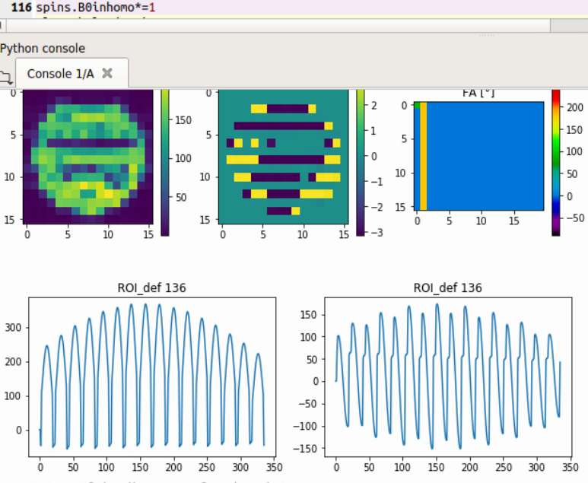 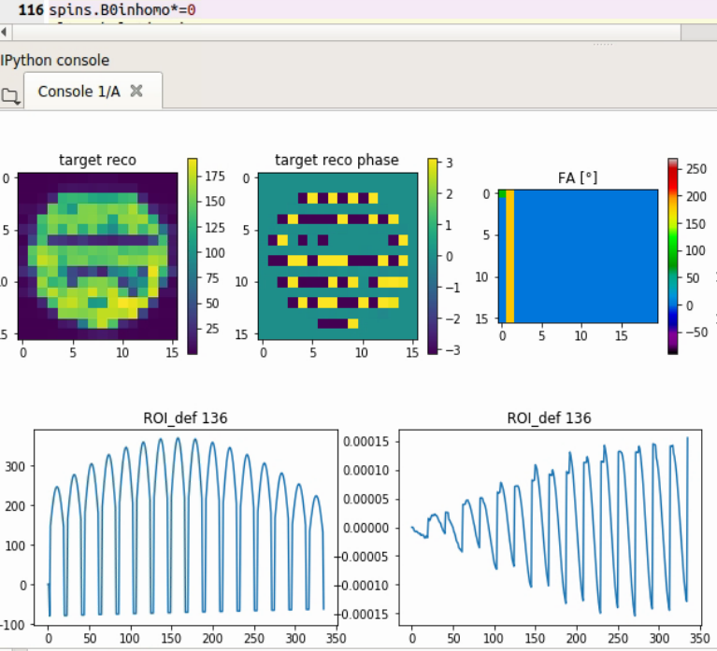

If inhomogeneity = 0, the y-component is almost zero.

This is not a bug at all, this shows exactly the refocusing of the dephasing due to B0inhom

**The same RARE seq yields crap when using forward fast**

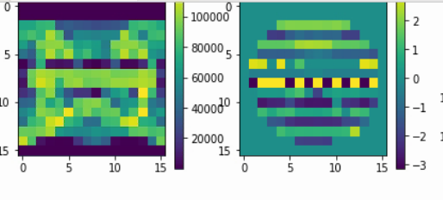

**11.04.2019**

**Gradmoms form pulseq and simulation now fit perfectly.**

**The last dot in the grads is for some reason necessary in pulseq. The ADC is always one step longer. We still have to understand that.**



**8.4.2019**

* **Restliche Sachen sollten nochmal slabselective gemessen werden, evtl mehr stabile exportieren**
* **Evtl gz komplett balancen**
* **Try same sequence in vivo**

**7.4.2019**

**What I found out today:**

* **TR=20 ms sequence works and is a reasonable sequence for optimization (fast enough)**
* **Optimized sequence also yields images … still some artifacts not in agreement with sim, maybe due to 20 ms TR and higher echoes.**
* **Gradient optimization sequence works ok**
* **Gradient and flip optimization works ok and yields funny results with very high SAR**
* **To have most flexible optimization a SAR penalty is needed. Lambda of 0.5-2 might be enough.**
* **Slice selection works for target as well as for optimization**
* **Slice selection actually helps to retrieve the very low signals that were found in the right side of the phantom, this was thus due to B0 artufacts and in slice dephasing, now solved with 5mm slice.**
* **Orientation of phantom in final reco plot is flipped up down I think**



**Optimization without SAR restriction Optimization with SAR restriction**

**6.4.2019 - 1**

**Still struggling with the ADCs and gradmoms**

* Pulseq also has some errors when sending zero grad events. Fucked up some lines in my case.
* we now use the convention that ADC is acquired first.
* Pulseq still requires a full gradient until the end of the sampling ( so 16 gradient steps for 16 resolution) not only 15
* Thus in the sequence files we actually change nothing, also not the ADC mask. The ADC first is in the scanner class, but should be transparent.
* Old all_iters can still be exported as the sequence definition did not change. Actually only the adjoints needed for the reco will change when used with gradmoms from sim. Gradmoms form pulseq should be as well transparent.

**ADC is always on until the end of the read gradient:**

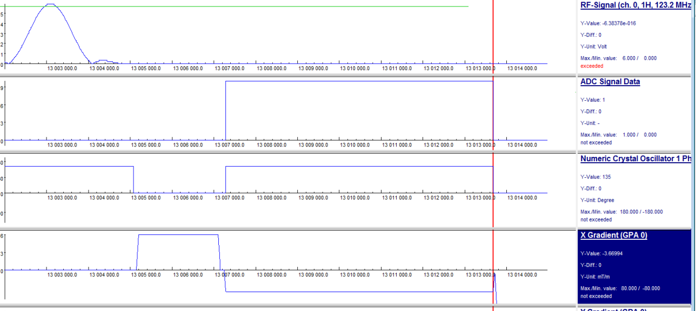

**03.04.2019**

Figures in: seq190402__e06_tgtGRE_tsk_GRE_no_grad_16_1kspins_lr0.7_onlyrewind

We made the following observation:

The gradient moments seem off for some reason.

Using the adjoint with the gradmoms given in pulseq actually solved the problem

**27.03.2019**

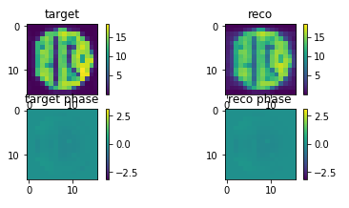

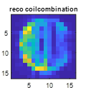****

**Left GRE, right lowSAR GRE**

**Numerical phantom added from measured 2D phantom.**

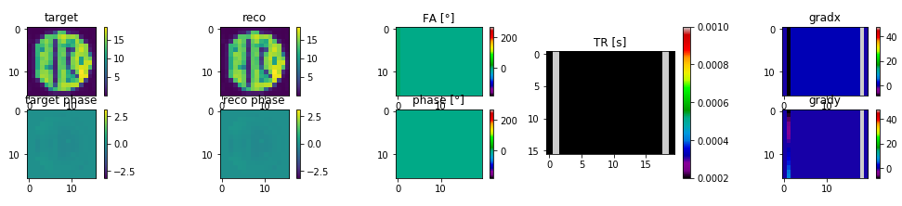

**check for spoiling here: Nspins min 25^2**

**Div by sz-1**

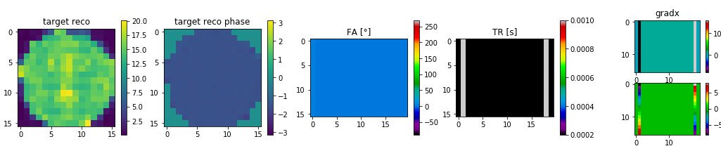

**Div by sz**

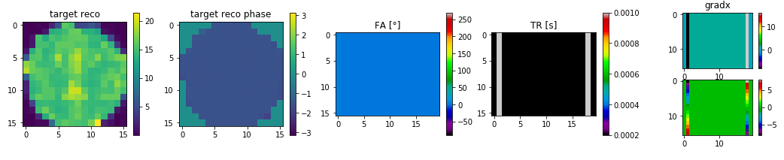

**12^2 spins**

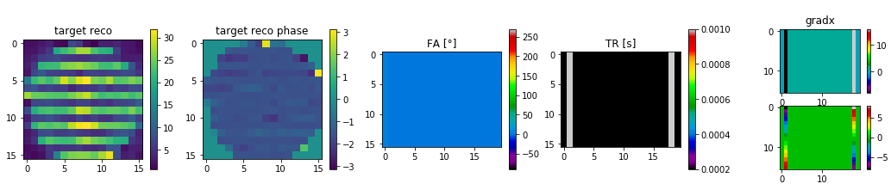

**Spin distribution within voxel, off=0**

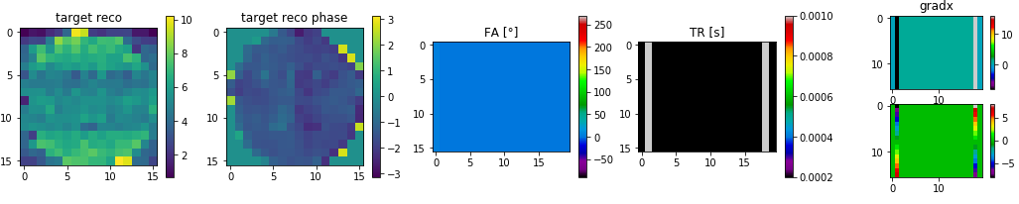

**Spin distribution within voxel, off=1/dim**

**26^2 spins**

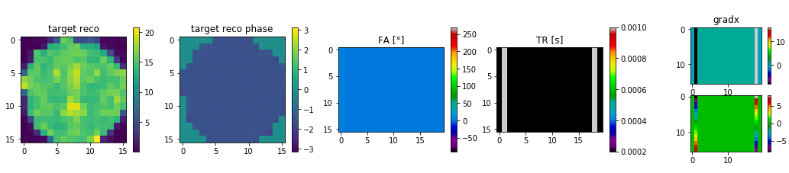

**Spin distribution within voxel, off=0**

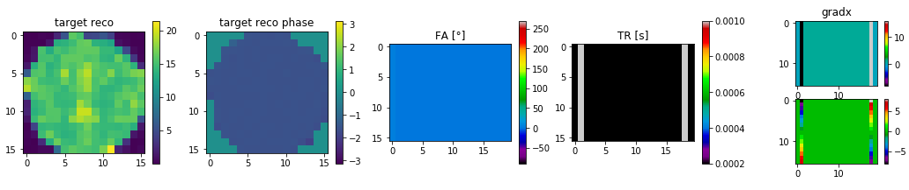

**Spin distribution within voxel, off=1/dim**

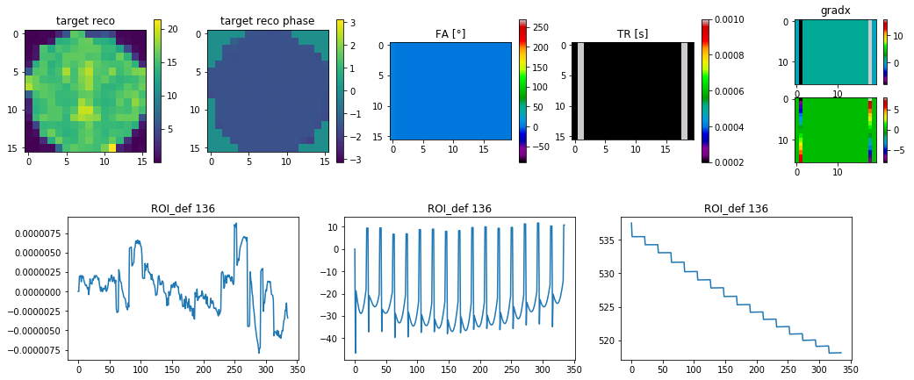

**Spoiled GRE: With pervec**

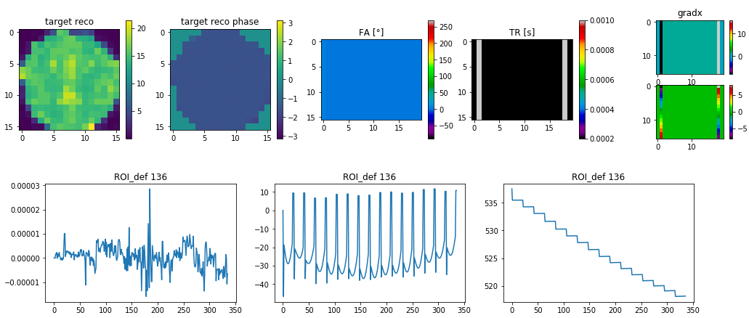

**Spoiled GRE: Without pervec**

**27.03.2019**

**Low SAR GRE optimized**



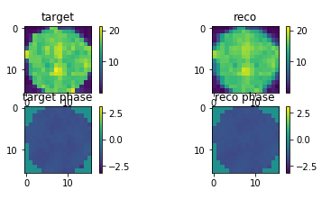



**Hooray!**

**26.03.2019**

**Try the following experiments:**

1. spoiled GRE (RF and gradient) x2negy****
2. **spoiled GRE (RF spoiled x2y2**



1. unspoiled GRE (Rf spoiled, no gradient)



1. **unspoiled (no grad, no RF)**



**25.03.2019**

found problem deep in sumulation: we modeled until now deltafunction, now change to continuum

**11.03.2019 – RARE 2D with spoilers added**

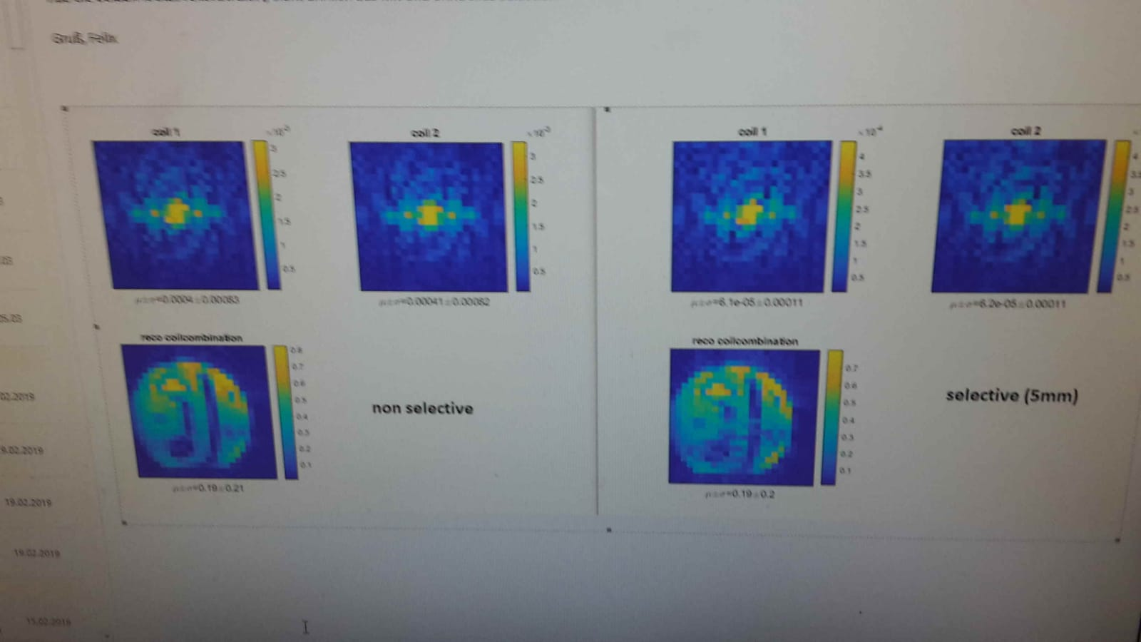

**11.03.2019 – first RARE 2D results – no spoilers**

